Design process
The findings of Study 1 to 5 were used to produce initial design ideas for a design intervention. The main purpose at this ideation stage was to explore different approaches to support people in managing inquiries with unknown time costs. Sketches were made to investigate what the interaction would look like for these different ideas, and if they were deemed an appropriate tool to address the issues found in the studies. The final idea was chosen to develop further as the final intervention, and the other ideas were not developed further beyond sketches. The process resulted in four ideas: the first three ideas are presented and described briefly below. The final design intervention is discussed in more detail.

To-do list
The first idea considers a task pane embedded in the data entry interface (see Figure 1), that enables users to write down the inquiries that are needed as part of a task. As was found in Study 1 and 2, people may not always know they need information until they have already started a task. Rather than interrupting a task to look up information straight away, the to-do list enables people to set a reminder to look this up later at a more convenient moment in the task. Users have the freedom to decide to look information up themselves when they want, from both digital and non-digital sources.

A to-do list requires people to spend time writing down the intention to interrupt, and they still have to switch away from the data entry interface to look up information. Furthermore, people may not make the effort to write it down if the interruption is presumed to be short.

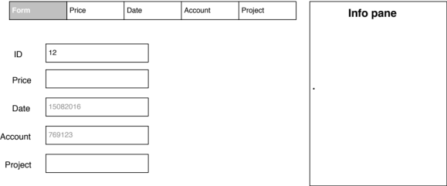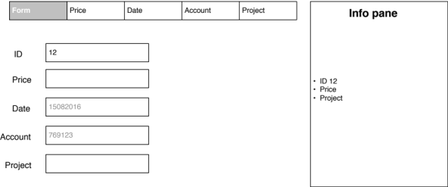
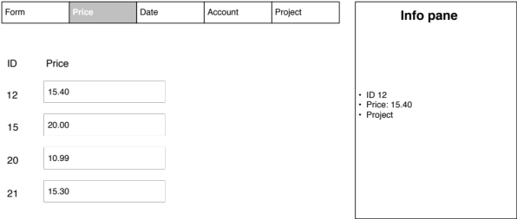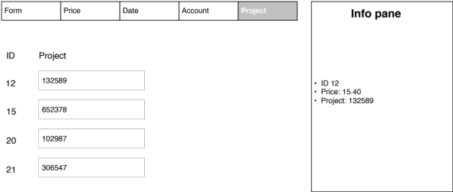
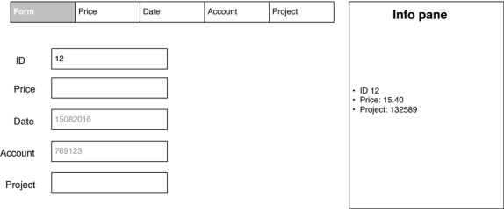

Pinboard
The idea of a pinboard extends the first idea of a to-do list. The pinboard not only allows people to write down inquiries, but also enables the user to place the information in the task pane, once it has been retrieved (see Figure 2).
Once they have found information, they can ‘pin’ this information source on their board, so if they need it to re-use this information again for future data entry tasks, they can look it up from the task pane and do not have to leave the interface and search for it again.

The information pane to pin and write down information is embedded in the main task interface, so the user does not have to switch to a separate application to search or view information, and the information is at hand when needed.

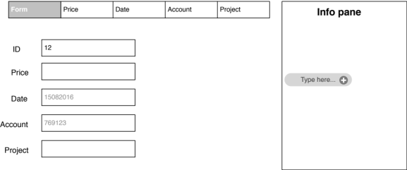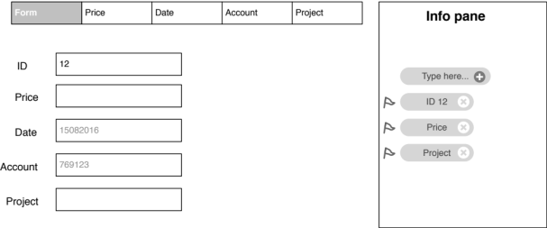
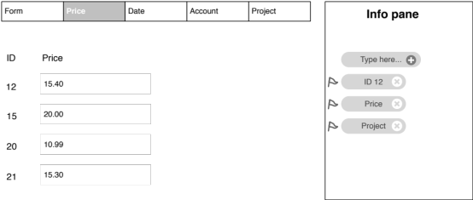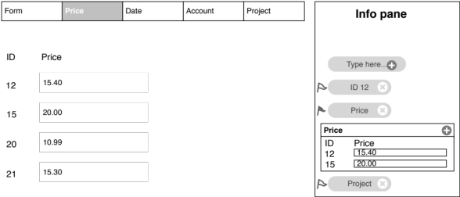
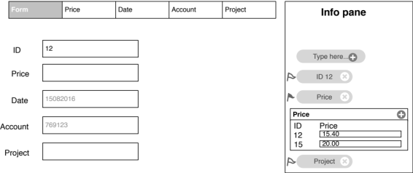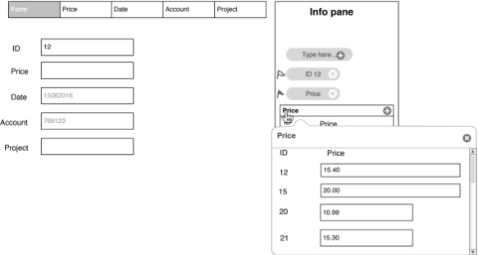

Search function
The search function revolves around the idea of minimising the time spent away from a task interface to look for information. A search function allows users to search within the task pane for new information (see Figure 3).
A snippet of search results is shown in the task pane, and the user can click on one of the search results to expand the information source and view the information.

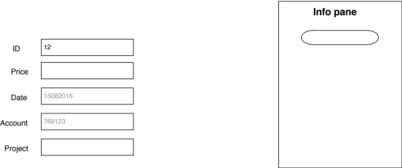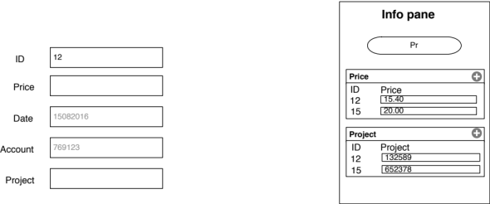
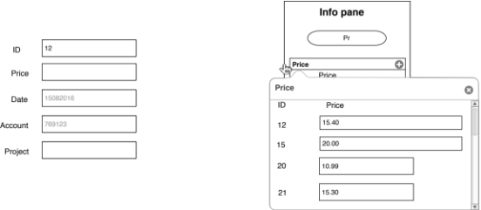

Time feedback: development of the design intervention
The first three ideas revolved around reducing the number or duration of people’s interruptions. However, these ideas would not necessarily make people more aware of the time they spend on interruptions, which was found to be a potential issue in Study 2. Upon reflection on these ideas, I was uncertain whether people would be willing to invest time in using a tool, if they would still be under the impression that their interruptions were short and not disruptive.
I therefore focused on developing a design intervention that would also make people more aware of time costs of interruptions, and whether this increased awareness would encourage people to reduce the number and duration of interruptions themselves. To increase awareness, the idea of a notification was developed that would give people feedback on their interruption behaviour. The notification gave information about the time people spent on interruptions, to see whether showing this information would reduce the duration and number of interruptions.

The moment of feedback
A first design consideration in developing the intervention was how the information should be presented to the user. Previous research found that users find it difficult to put reflective information about their use of time into context (Collins; Whittaker). Instead, giving feedback about task performance during a task has been shown to make users adjust their task strategies in the moment (Maior; Gould; Whittaker). It was therefore decided that, for the information to be most effective, it should appear during a task. To make people more aware of their interruptions, information is shown upon every interruption away from a primary task.
A second consideration was at which moment of an interruption the information should be shown: before or after an interruption. It was decided to show the information at the start of an interruption, so the user would be able to apply potential adjustments to their interruption behaviour immediately for that particular interruption. If information had been shown after an interruption, the interruption would have already taken place, and the user would have to remember to change their behaviour for future interruptions.

The type of time feedback
As the information is shown at the start of an interruption, it is difficult to provide any accurate information about the exact duration of the interruption that is about to take place. Therefore, the intervention shows the average interruption time of all previous interruptions, to give an indication how long the interruption could take, based on past behaviour. The intervention considers the average time of all digital interruptions away from a specific task, that is when the user switches from a specific task to another computer window.
The intervention considers the time of an interruption overall, and not just time spent in a particular application or website the user switches to. Even though interruptions may be expected to take longer if the user switches to a distracting source, the user may visit several windows during an interruption before returning to the task, behaviour which was commonly observed in Study 2. The time spent in a specific source may therefore not give an accurate picture of the overall duration of interruptions, as people may only stay in the first window for a short time but the overall interruption may take much longer.

Task sequence
The information was presented to the user through a notification. Figure 4 shows what the interaction with the design intervention would look like. Step 1 shows the window of an expenses task the user has to complete. To complete this type of task, information needs to be retrieved by switching to another window (Step 2). Upon every switch away from the task interface, a notification appears telling the user how long these switches are on average. If the user switches for the first time, the notification says that no data is available yet to give an average time. Once the right information has been found, the user then has to switch back and enter this information in the correct field (Step 3).

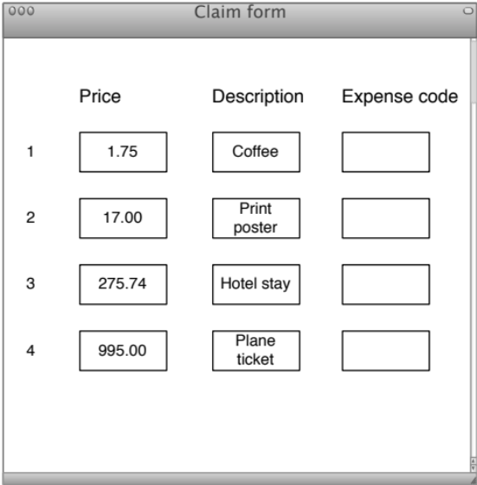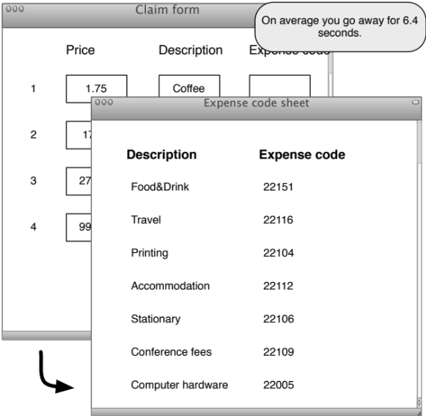
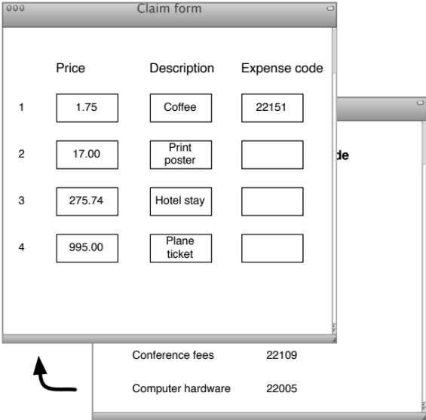

Implementation
The intervention was implemented as a browser notification. As was found in Chapter 3, participants’ data entry work was conducted in a web browser and revolved around a main data entry web page. Every switch between the task page and another computer window, such as another browser window or a different application, were recorded to calculate the number and duration of switches. The browser notification used this data to show users the average time of their interruptions.
The notification was evaluated in an online experiment in Study 6, and in an office workplace in Study 7. The visual presentation of the notification to participants was the same in both studies, but because of the different study environments, the implementation differed slightly between studies. In Study 6, the browser notification was implemented in the experimental data entry interface. In Study 7, the browser notification was implemented as a browser extension that the participants could install on their own computer and use on any website they wanted. The implementation details are further discussed in the separate study sections. The notification was evaluated in a pilot study with colleagues before using it in the studies.

